Edge Intelligence
Lab 10

Gowtham v
25MML0046

Design and implement the pipeline for object detection in Videos using Yolov8

Architecture
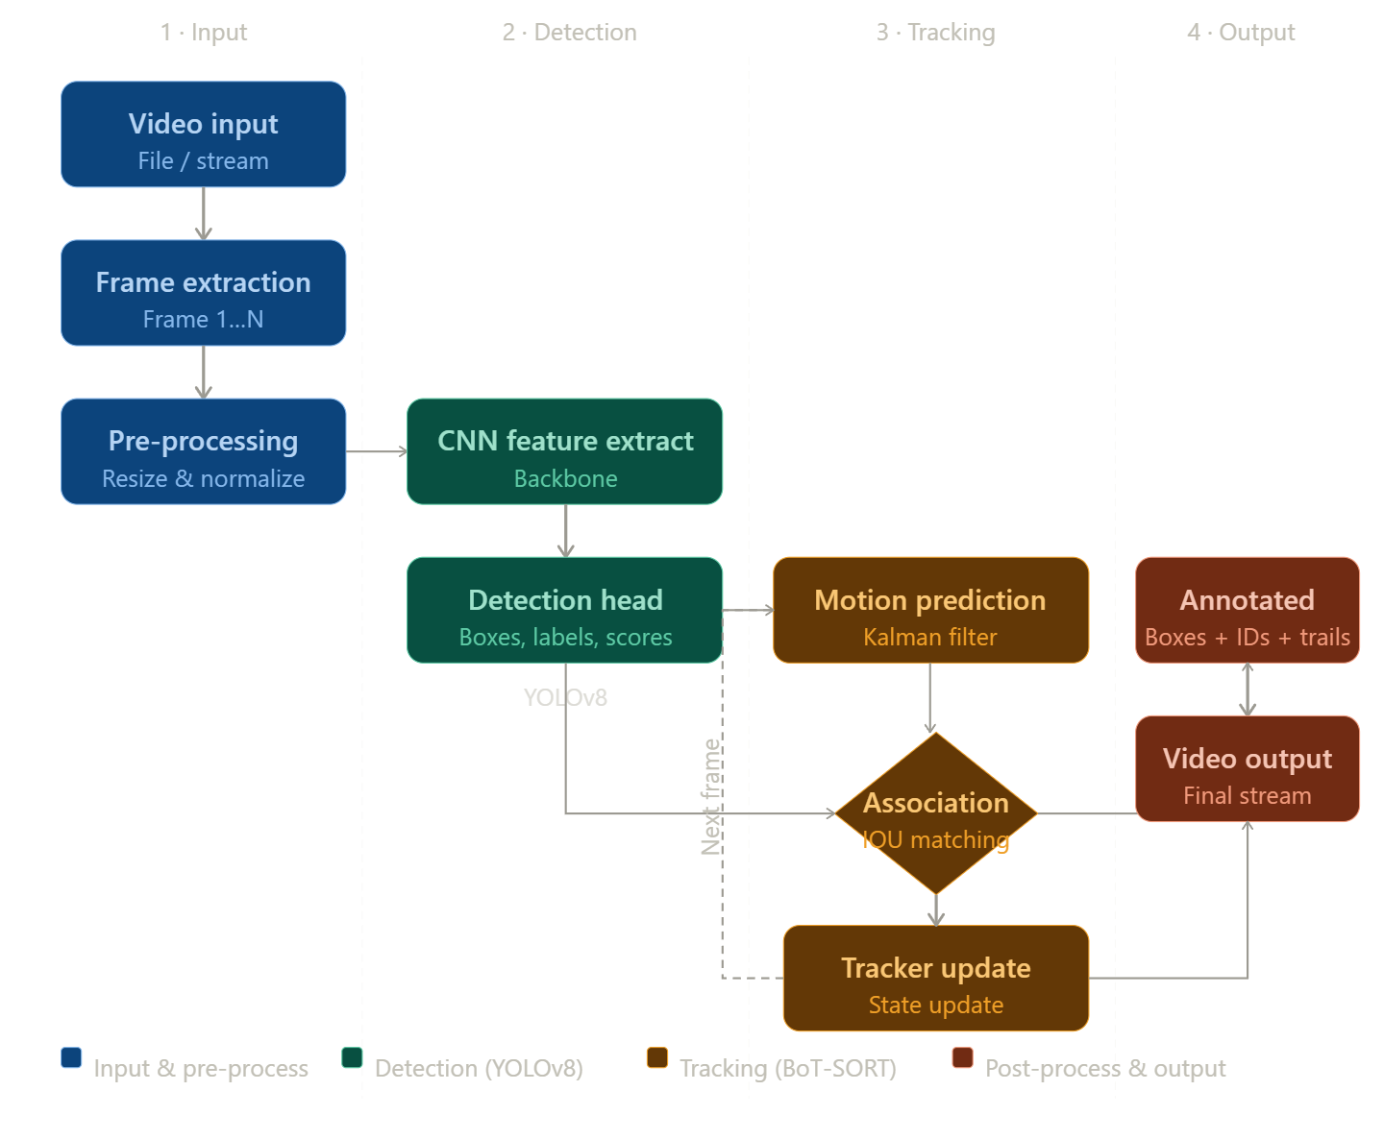

Code
# 1. Install dependencies
!pip install ultralytics

import cv2
from ultralytics import YOLO
from google.colab.patches import cv2_imshow from IPython.display import clear_output

# 2. Load the YOLOv8 model model = YOLO("yolov8n.pt")

# 3. Path to your video (Ensure you upload the file to Colab first) video_path = "/content/026c7465-309fbd33.mp4"
cap = cv2.VideoCapture(video_path)

# Loop through the video frames while cap.isOpened():
success, frame = cap.read()

if success:
# 4. Run YOLOv8 tracking (same logic as your code) # results is a list, so we take results[0]
results = model.track(frame, persist=True, tracker="botsort.yaml")

# 5. Visualize the results annotated_frame = results[0].plot()

# 6. Colab-specific display logic
clear_output(wait=True) # Clears previous frame for smooth display cv2_imshow(annotated_frame)
else:
break
cap.release() cv2.destroyAllWindows()

Output
